GEIT3351: Principles of Software Eng'g_103
Submitted to: Dr. Maen Mohammad
By:
Saeed Al-Ghamdi -202201694
Bader Al-Qahtani - 202301754
Project Report: PMU Bank of Clothes
3 May 2026

Introduction
The PMU Bank of Clothes system is an online platform designed to facilitate the donation and distribution of clothes among students and visitors at Prince Mohammad Bin Fahd University. The system allows users to create accounts, donate clothes, and request items based on their needs. The goal of this system is to promote sustainability, reduce waste, and support individuals in need within the university community. The system is designed to be user-friendly, efficient, and accessible.

Requirements Analysis
The stakeholders of the system include:
- PMU Students: who donate and request clothes.
- University Management (Admin): who manages the system, approves donations, and oversees the platform.
- Beneficiaries (Students in Need): who request and receive clothes through the system.

User Stories:
- Account Registration
Users can create a new account.
User Story:
As a user, I want to create an account so that I can access the system.

- Login System
Users can log into their accounts.
User Story:
As a user, I want to log in so that I can use my account features.

- Donate Clothes
Users can donate clothes through the system.
User Story:
As a user, I want to donate clothes so that others can benefit from them.

- Request Clothes
Beneficiaries can request available clothes through the system.
User Story:
As a user, I want to request clothes so that I can receive items I need.

- View Available Clothes
Beneficiaries can browse donated clothes.
User Story:
As a user, I want to view available clothes so that I can choose what I need.

- Admin Approval System
Admin reviews and approves donations.
User Story:
As an admin, I want to approve or reject donations so that only valid items are listed.

- Track Requests / Donations
Users can see status of their requests/donations.
User Story:
As a user, I want to track my requests so that I know their status.

- Notification System
Users receive updates.
User Story:
As a user, I want to receive notifications so that I stay informed about my activity.

UML use-case diagram:
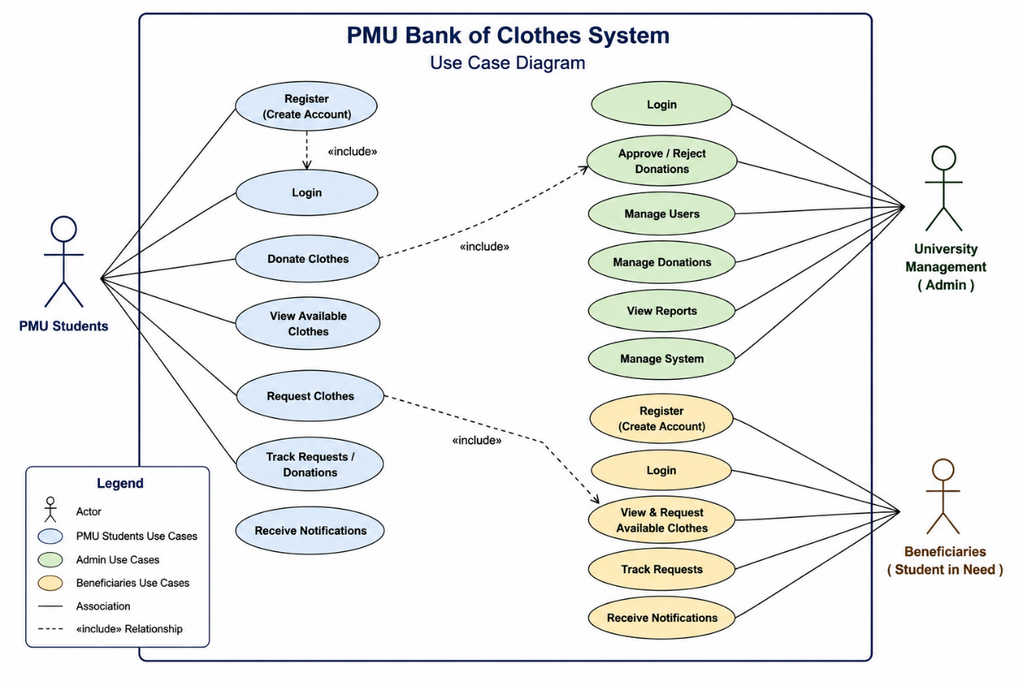

Non-Functional Requirements:
- The system should load within 2 seconds.
- The system should ensure secure login (authentication).
- The system should be user-friendly and easy to navigate.
- The system should be accessible on mobile devices.

System Design
System Architecture
The PMU Bank of Clothes System follows a client-server architecture composed of three primary layers:
• Client Side (Presentation Layer)
The client side represents the graphical user interface accessible through modern web browsers. It is developed using HTML, CSS, and JavaScript. This layer handles user interactions, displays clothing inventory, manages forms, and provides navigation between different system modules.

• Server Side (Application Layer)
The server side is responsible for processing business logic and handling communication between the user interface and the database. This layer manages authentication, donation processing, request validation, administrative approvals, and notification handling.
• Database Layer (Data Layer)

The database layer stores all persistent system data, including user accounts, clothing donations, requests, approvals, and inventory records. This layer ensures efficient data storage, retrieval, and management.

UML Class Design
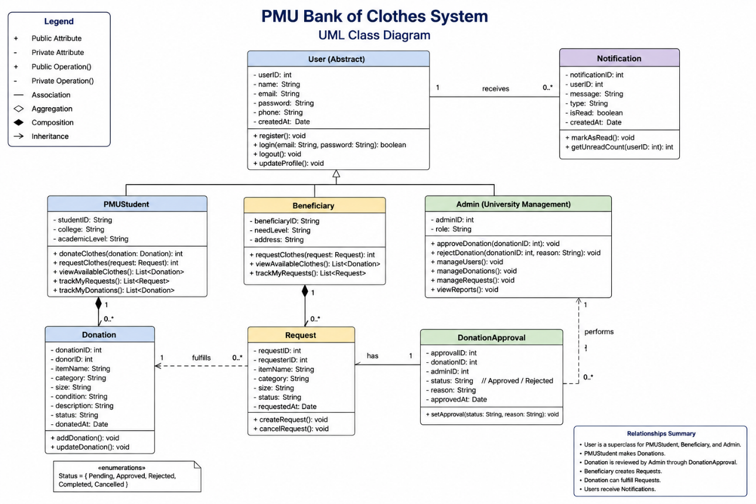

Database design (ER/Schema):
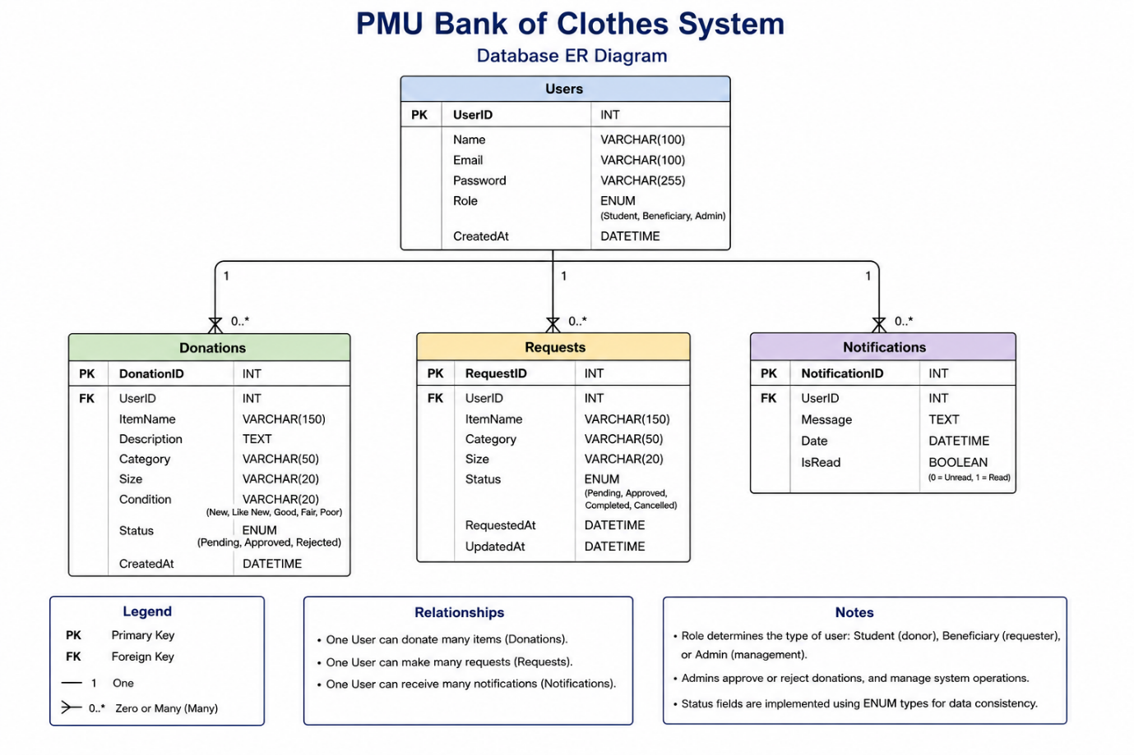
GUI Design (Figma):
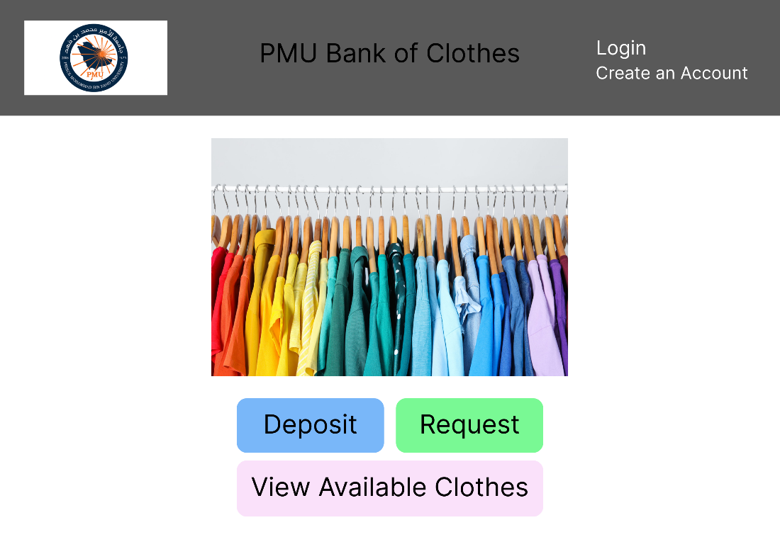
Home Page - 1

Login Page - 2
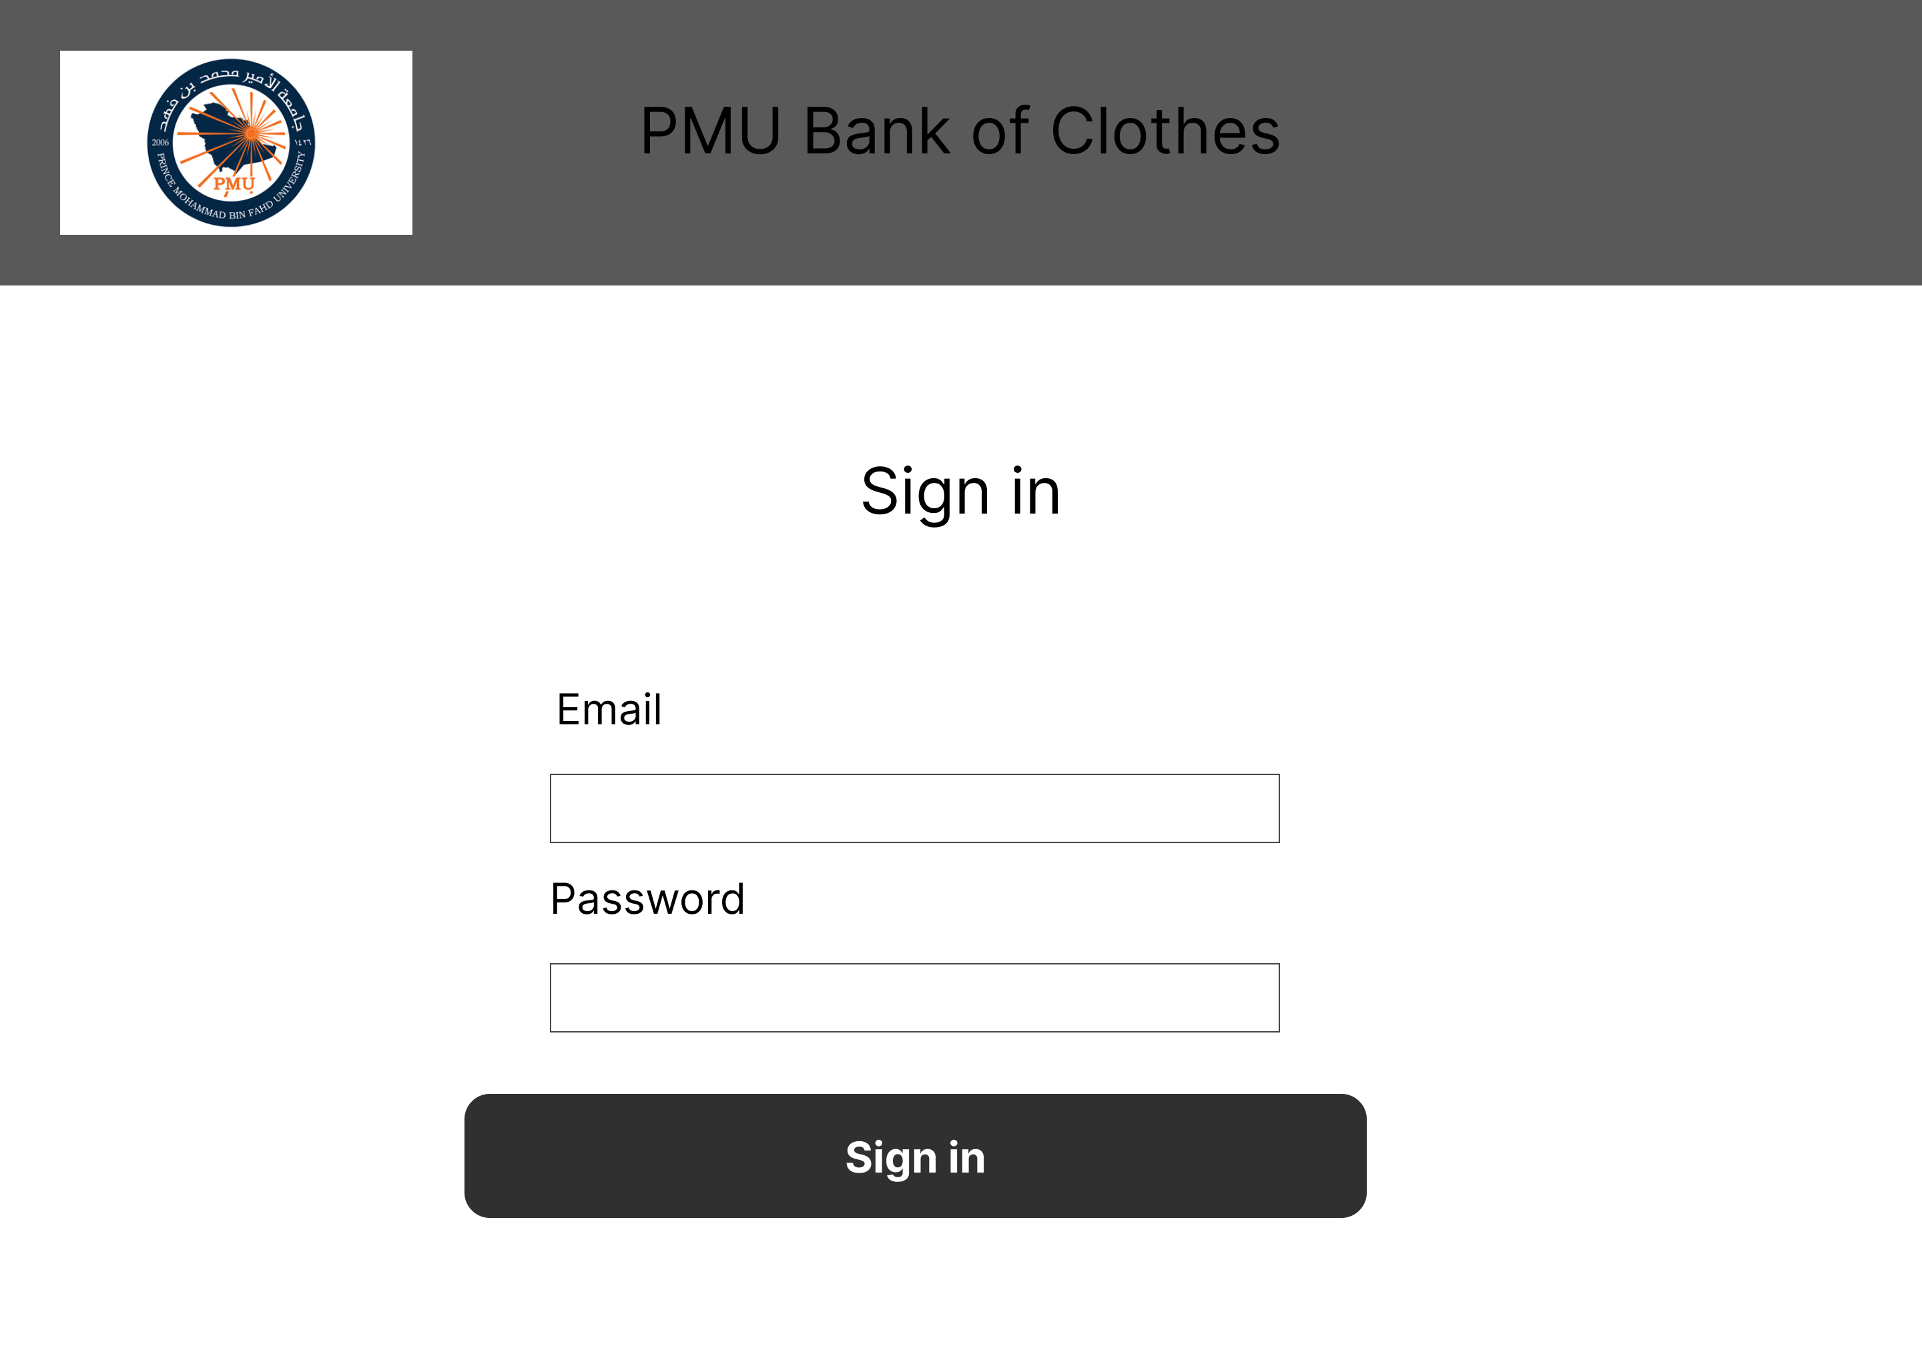
Create an Account Page - 3
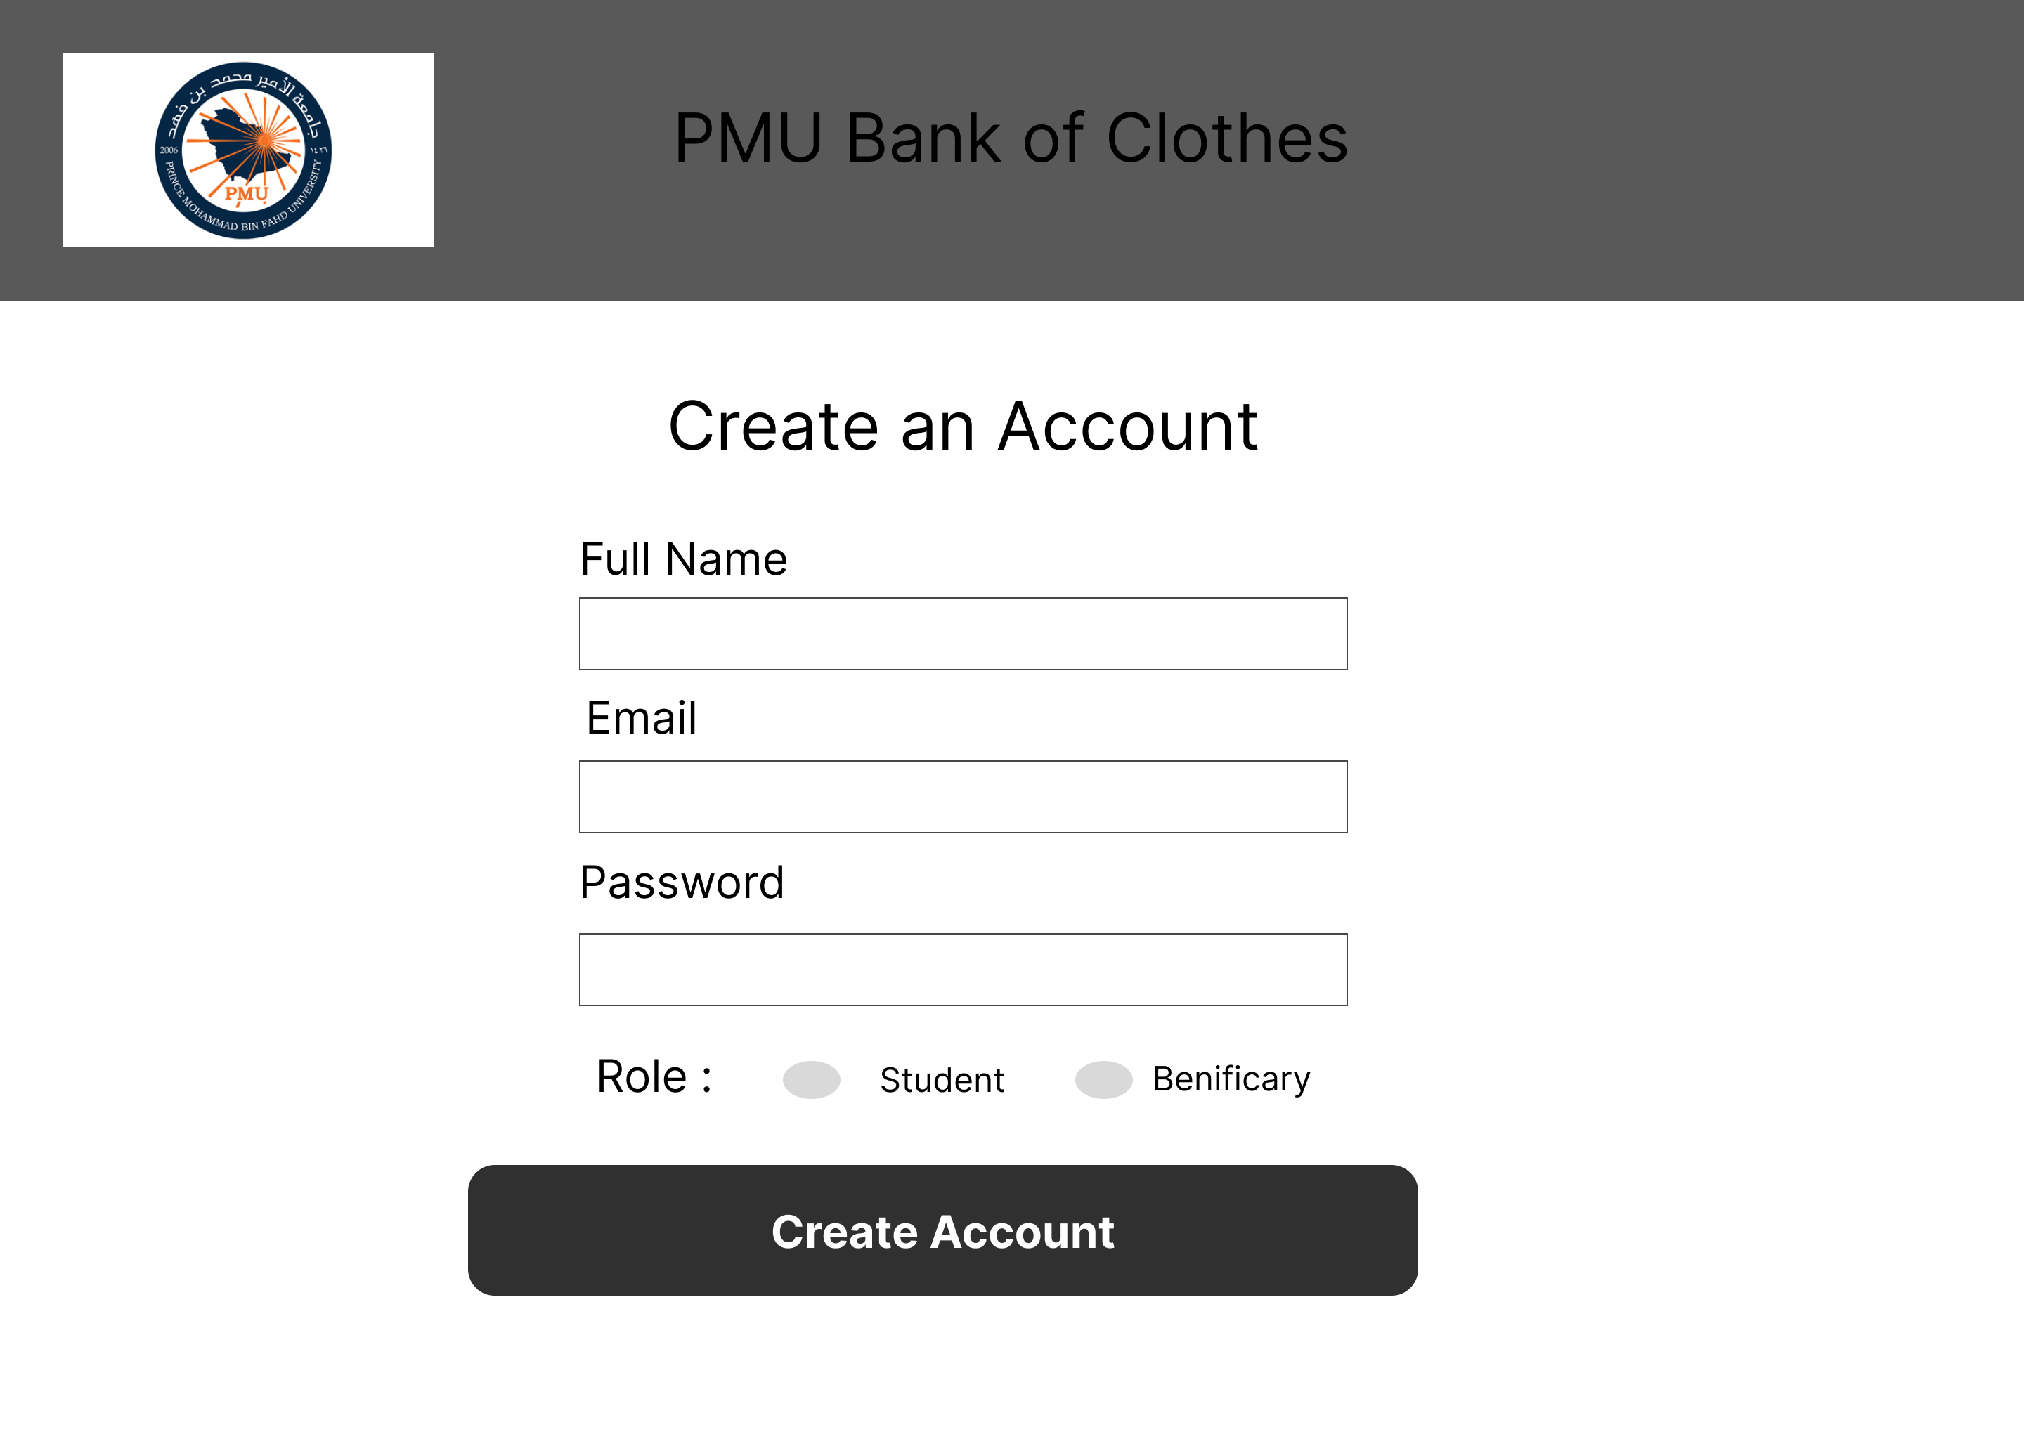

Donation Page - 4
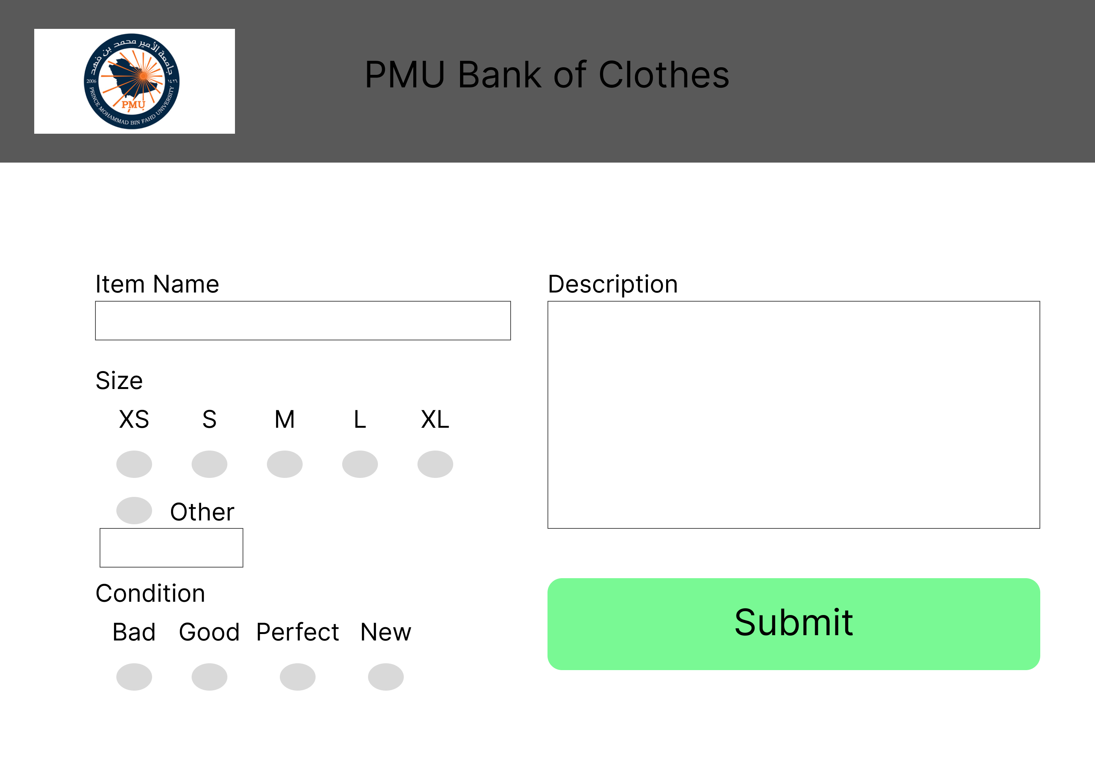
Request Page - 5
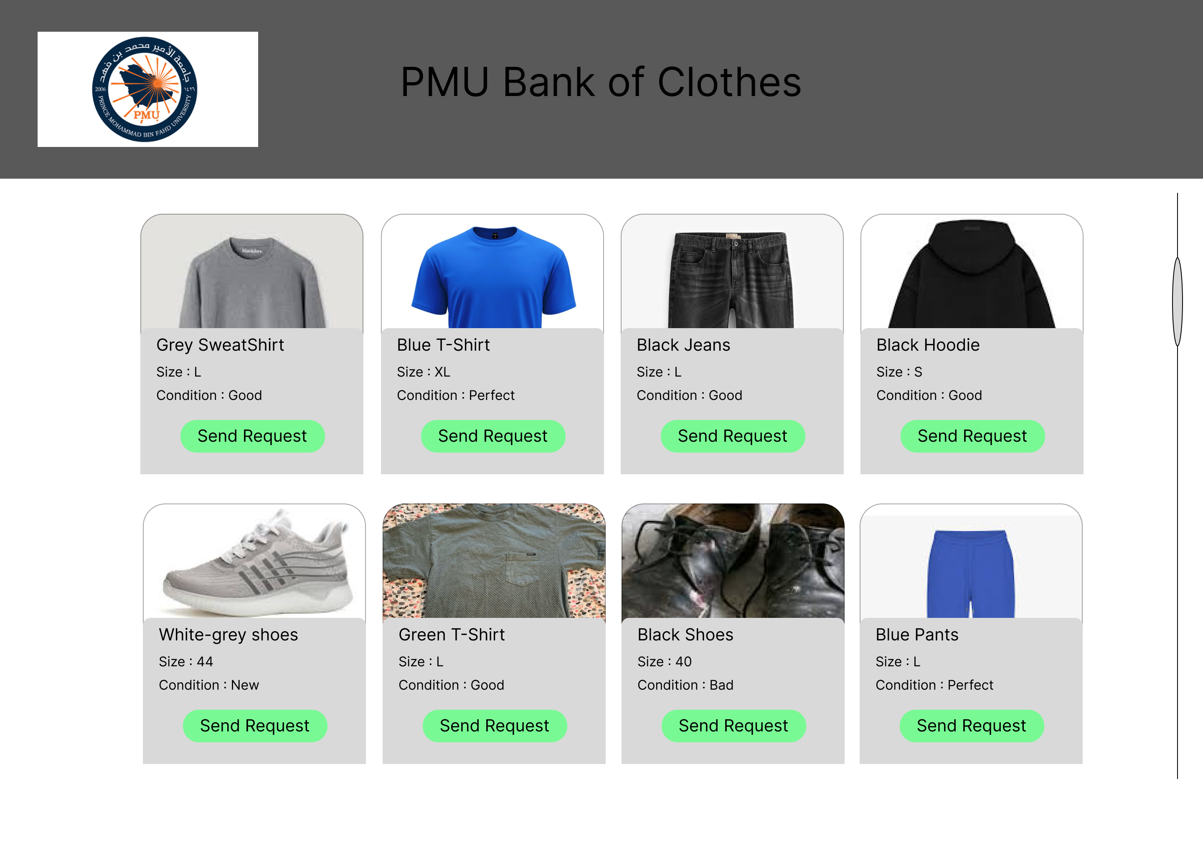
Link for Figma Design: https://www.figma.com/proto/WlSBbs53NX3FmxljGxOFBA/Untitled?node-id=0-1&t=ooMtttTKH84jWIt6-1

Implementation
The create account page was implemented using HTML, CSS, and JavaScript. The page allows users to enter their personal information and create an account. Basic validation is included to ensure that passwords match before submission.
Link for GitHub Code :

Testing
Feature: Account Registration
Test Case 1:
Input: Valid name, email, password, and matching confirm password
Expected Result: Account is created successfully
Test Case 2:
Input: Password and confirm password do not match
Expected Result: Error message "Passwords do not match" is displayed

Feature: Login System
Test Case 1:
Input: Correct email and password
Expected Result: User logs in successfully
Test Case 2:
Input: Incorrect password
Expected Result: Error message is displayed

Feature: Donate Clothes
Test Case 1:
Input: Valid clothing item details
Expected Result: Donation is submitted successfully
Test Case 2:
Input: Missing item information
Expected Result: Error message is displayed

Feature: View Available Clothes
Test Case 1:
Input: User opens available clothes page
Expected Result: List of clothes is displayed
Test Case 2:
Input: No clothes available
Expected Result: Message "No items available" is shown

Feature: Request Clothes
Test Case 1:
Input: Beneficiary selects an available item and submits a request.
Expected Result: Clothing request is successfully submitted.
Test Case 2:
Input: User submits request without selecting item
Expected Result: Error message is displayed

